Be-mindpower Super Admin Panel

Project Specification & Master Plan

Document Control

Project Name BMP Super Admin Panel
Version 1.0 (Client Release)
Date February 17, 2026
Prepared For Be-mindpower Stakeholders
Status In Development

Table of Contents
Executive Summary
Project Scope & Deliverables
System Architecture
Implementation Roadmap
Project Timeline

Executive Summary

The BMP Super Admin Panel is a mission-critical infrastructure project designed to
centralize the management of the "Be-mindpower" platform. As the platform scales, the need for a unified interface to oversee user lifecycles, subscription health, and mass communication has become paramount.
This solution delivers a secure, high-performance dashboard that allows administrators to:
- Manage Users: Gain 360-degree visibility into customer data and enforce compliance (blocking/unblocking).
- Drive Engagement: Execute targeted bulk notification campaigns via Email and Push channels.
- Ensure Security: Operate within a secure environment with strict Role-Based Access Control (RBAC), completely separating internal staff from customer accounts.

Project Scope & Deliverables

Core Functionality
🛡 User Management Module

    - Centralized Directory: A real-time, searchable database of all registered users.
    - Smart Filtering: Instantly segment users by:
      - Subscription Tier (Free vs. Premium)
      - Payment Health (Good Standing vs. Overdue)
      - Account Status (Active vs. Blocked)

Administrative Actions:
      - Block/Unblock: Immediate suspension of access for security or payment
      - Profile Audit: Granular view of user activity and plan history
      - Trial Management: Increase, decrease, or end user free trial periods directly via Stripe integration.

Advanced Notification Engine

Multi-Channel Delivery:
      - SMTP Email: For official notices, receipts, and newsletters.
      - Firebase Push: For instant alerts and engagement nudges.

Intelligent Segments:
      - No Plan: Target users for conversion/upsell.
      - Payment Due: Automated reminders to reduce churn.
      - ⏳ Grace Period: Critical retention alerts before service cutoff.
    - Performance: Background job processing ensures 99.9% delivery reliability without impacting dashboard performance.

Feature Status Matrix

Module | Feature | System Status
Security | Admin Authentication & Session Management | Todo
Users | User Listing, Searching & Filtering | Todo
Users | Block/Unblock Logic | Todo
Messaging | Bulk Notification Composer | Todo
Messaging | Queue Worker & Delivery | Todo
Payments | Modify Stripe Trial Period (Admin Panel) | Todo

System Architecture

Our architecture prioritizes Scalability, Security, and Maintainability.

Data Flow Diagram (DFD)
Visualizing the secure flow of data from Admin actions to End-User delivery.

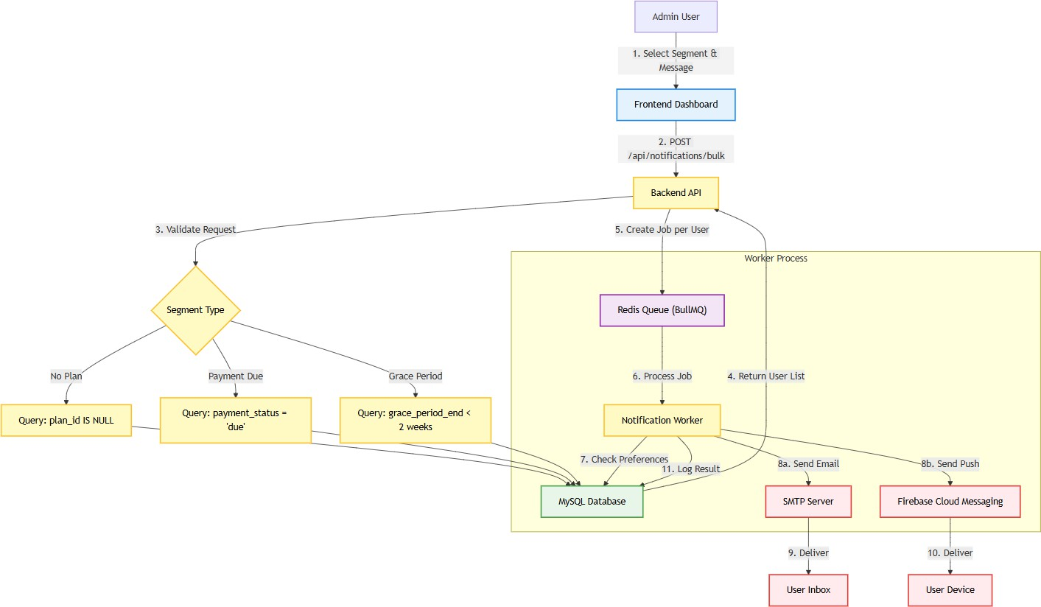
Sequence Diagram

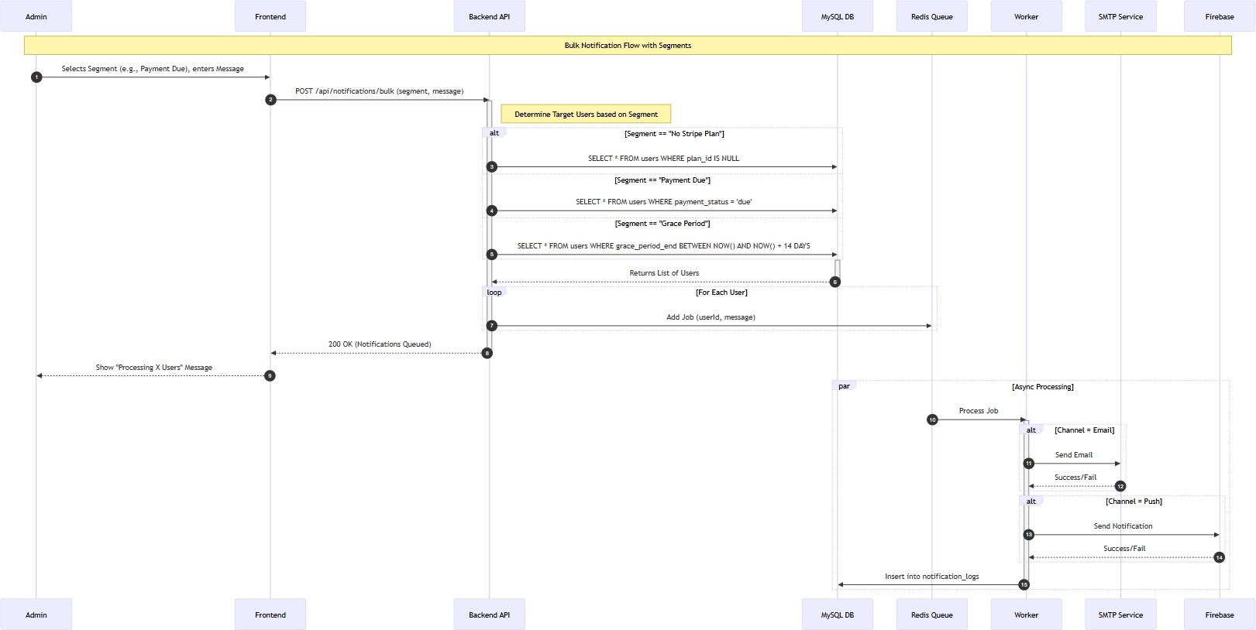
Detailed interaction flow for the Bulk Notification process.

Entity Relationship Diagram (ERD)
Database schema highlighting the secure separation of System Admins and Customers.

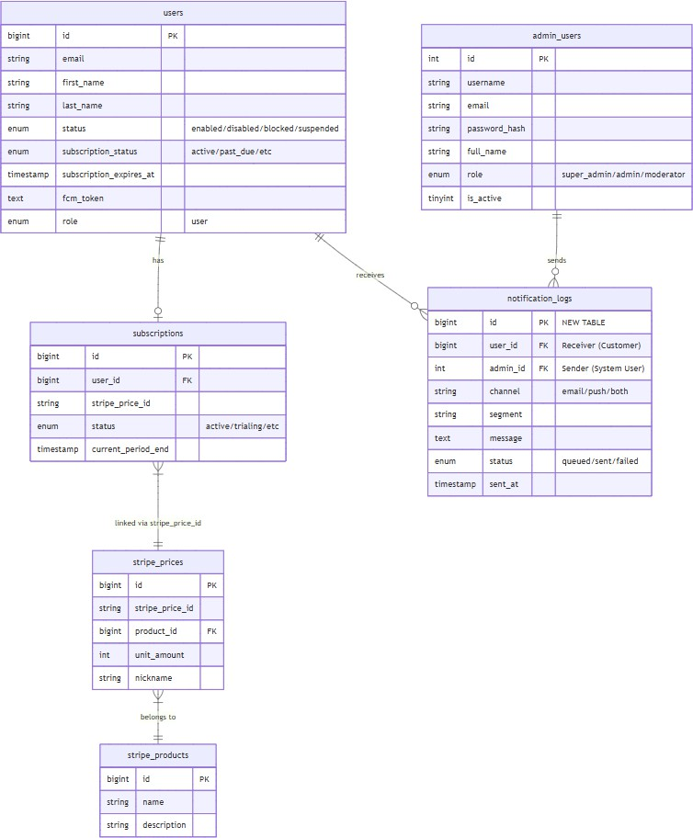
Implementation Roadmap

Phase 1: Foundation

Core Infrastructure Setup

[x] Project Initialization (Node.js API & React Dashboard).
[x] Database Design & Connectivity (AWS RDS).
[x] External Services Integration (Firebase, SMTP, Redis).

Phase 2: Development

Feature Implementation (Current Phase)

- [ ] Security Hardening: Implementation of distinct admin_users authentication tables.
- [ ] User Actions: Finalizing logic for global vs. feature-specific user blocking.
- [ ] Notification Logic: Wiring the Queue Worker to live email/push providers.

Phase 3: Launch

Verification & Deployment

- [ ] QA Testing: End-to-End validation of all admin workflows.
- [ ] Production Deployment: Release to live environment.
- [ ] Handoff: Delivery of technical documentation and admin guides.

Project Timeline

Milestone | Estimated Completion
Phase 1 (Foundation) | Completed
Phase 2 (Development) | In Progress
Phase 3 (Testing & Launch) | Early March 2026

Note: Timeline is subject to prompt feedback cycles and valid access to third-party services.

© 2026 Be-mindpower. Confidential & Proprietary.

